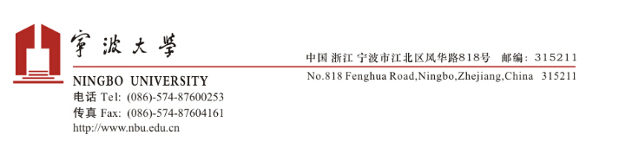
Bisheng Du, Professor, PhD
Business School, Ningbo University
Email: dubisheng@nbu.edu.cn
Mobile: +86-186xxxxxxxx
Web: www.dubisheng.com

January 1, 2022

To Whom It May Concern:

Sincerely,

Bisheng Du

